# Supplementary material part 1: Sensitivity analyses of the results according to different landscape structure

## Introduction

Because fragmentation, habitat destruction and climate warming act synergistically on species persistence (Travis 2003[1]; Opdam and Wascher 2004[2]), we tested the generality of our results according to landscape configuration for the following thermal performance curve:

$$TP= e^{-\frac{{\left(x-(x_{opt}+x_{adap})\right)}^{2}}{{100*T}_{breadth}}}∙{TP}_{max}∙e^{-a*T_{breadth}}$$

Here, *TP* refers to the thermal performance of an individual and *TPmax* to the maximum value of *TP*. *a* represents a flexible parameter describing the strength of the performance (*umax*) – thermal breadth (*Tbreadth*)trade-off equaling 1 or 10. We contrasted cases where the optimum is evolvable or not and discuss first the ecological dynamics (population persistence) continued by a detailed overview of the results on ES dispersal, thermal breath and thermal optimum. Because landscape configuration did not impacted the evolutionary dynamics, we provide a synthesizing discussion at the end.

## Methods

Landscape typology: The spatial configuration of the suitable habitat is determined by two parameters, *P* and *H.* *P* represents the proportion of suitable habitat and *H* the spatial autocorrelation of the landscape (i.e. measure for connectivity). By changing values of *P* (0.2, 0.5 or 0.8) or *H* (0.2 or 0.8), processes of habitat loss (by lowering of *P*) or habitat fragmentation (by lowering of *H*) are independently determined. The values for *P* and *H* are chosen in such a way that the effects of these processes on evolution can be optimally detected.

Generation of landscapes: Landscapes are generated by applying the algorithm described by Chipperfield, Dytham, and Hovestadt (2011)[3]. The initially generated landscape has dimensions 2048×2048 but only a small fraction (2048 x 100) of this surface is used. Hereby the landscape looses its periodicity (Keitt 2000; Chipperfield, Dytham, and Hovestadt 2011)3. Therefore, the boundaries of the climate window along the x-axis are reflecting when the effect of landscape configuration is investigated. The boundaries of the climate window parallel to the y-axis are always absorbing. For each type of simulation 50 replicates are used. Only once, 50 different landscapes per configuration type were generated. As such, survival chances in function of the landscape could be determined. Due to the high number of replicas, only 1000 individuals were sampled at each equilibrium.

Consequences for the lifecycle of an individual: Importantly, an individual will only be able to reproduce after arriving on suitable habitat within the climate window during the dispersal phase.

## Results & discussion: population persistence

Table S1.1:Comparison of survival chances between different landscape types (described by *H* and *P*) and scenarios in which *xadap* is evolvable or not when the competition-thermal breadth trade-off is weak (*a* fixed at 1).

|  |  |  |  |  |  |  |  |  |  |  |  |  |
| --- | --- | --- | --- | --- | --- | --- | --- | --- | --- | --- | --- | --- |
|  | *xadap* not evolvable | | | | | | *xadap* evolvable | | | | | |
| *P* | 0.2 | 0.2 | 0.5 | 0.5 | 0.8 | 0.8 | 0.2 | 0.2 | 0.5 | 0.5 | 0.8 | 0.8 |
| *H* | 0.2 | 0.8 | 0.2 | 0.8 | 0.2 | 0.8 | 0.2 | 0.8 | 0.2 | 0.8 | 0.2 | 0.8 |
| I | 88 | 56 | 96 | 72 | 100 | 94 | 88 | 56 | 96 | 72 | 100 | 94 |
| 1000 | 74 | 54 | 96 | 72 | 100 | 94 | 74 | 54 | 96 | 72 | 100 | 94 |
| 1050 | 64 | 42 | 86 | 66 | 100 | 94 | 60 | 42 | 84 | 66 | 98 | 94 |
| 1100 | 30 | 26 | 62 | 58 | 90 | 88 | 28 | 26 | 58 | 58 | 90 | 88 |
| 1200 | 4 | 14 | 48 | 36 | 84 | 84 | 4 | 14 | 46 | 36 | 86 | 84 |
| 1500 | - | 4 | 32 | 10 | 66 | 62 | - | 4 | 30 | 10 | 66 | 62 |
| 2000 | - | - | 6 | - | 54 | 26 | - | - | 4 | - | 54 | 26 |

The numbers represent the percentage of replicas out of 50 of which the initialization of individuals was successful (I) and of this number, the percentage of replicas containing more than 1000 individuals after 1000, 1050, 1100, 1200, 1500 or 2000 generations respectively. When estimating the effect of *xadap* as an evolvable trait, the numbers which are higher in one of both scenarios are highlighted.

Table S1.2:Comparison of survival chances between different landscape types (described by *H* and *P*) and scenarios in which *xadap* is evolvable or not when the competition-thermal breadth trade-off is strong (*a* fixed at 10).

|  |  |  |  |  |  |  |  |  |  |  |  |  |
| --- | --- | --- | --- | --- | --- | --- | --- | --- | --- | --- | --- | --- |
|  | *xadap* not evolvable | | | | | | *xadap* evolvable | | | | | |
| *P* | 0.2 | 0.2 | 0.5 | 0.5 | 0.8 | 0.8 | 0.2 | 0.2 | 0.5 | 0.5 | 0.8 | 0.8 |
| *H* | 0.2 | 0.8 | 0.2 | 0.8 | 0.2 | 0.8 | 0.2 | 0.8 | 0.2 | 0.8 | 0.2 | 0.8 |
| I | 88 | 56 | 96 | 72 | 100 | 94 | 88 | 56 | 96 | 72 | 100 | 94 |
| 1000 | 74 | 56 | 96 | 72 | 100 | 94 | 74 | 54 | 96 | 72 | 100 | 94 |
| 1050 | 66 | 42 | 86 | 66 | 100 | 94 | 62 | 42 | 82 | 66 | 98 | 90 |
| 1100 | 32 | 26 | 62 | 58 | 90 | 88 | 30 | 26 | 58 | 58 | 92 | 88 |
| 1200 | 4 | 14 | 48 | 36 | 86 | 84 | 4 | 14 | 46 | 36 | 84 | 84 |
| 1500 | - | 4 | 32 | 10 | 68 | 62 | - | 2 | 30 | 10 | 66 | 62 |
| 2000 | - | - | 4 | - | 56 | 26 | - | - | 2 | - | 52 | 24 |

The numbers represent the percentage of replicas out of 50 of which the initialization of individuals was successful (I) and of this number, the percentage of replicas containing more than 1000 individuals after 1000, 1050, 1100, 1200, 1500 or 2000 generations respectively. When estimating the effect of *xadap* as an evolvable trait, the numbers which are higher in one of both scenarios are highlighted.

Survival probabilities during range shifting increase with *P* (percentage of suitable habitat in the landscape) (Table S1.2 and S1.2). A high value for *H* is positive for survival in short term. Still, after more than 1000 generations, landscapes with low habitat connectivity are more successful.

When the local thermal optimum (*xadap*) is not evolvable, survival chances are little higher compared to scenarios in which local adaptation of the thermal optimum is allowed (Table S1.1 & S1.2). This effect is more pronounced when the strength of the performance-thermal breadth trade-off is high (see Table S2.2).

## Results: evolutionary dynamics under non-evolvable optimum (a=10) in contrasting landscape configurations

Testing the effect of landscape configuration for a strong (*a*=10) performance-thermal breadth trade-off when *xadap* is not evolvable.

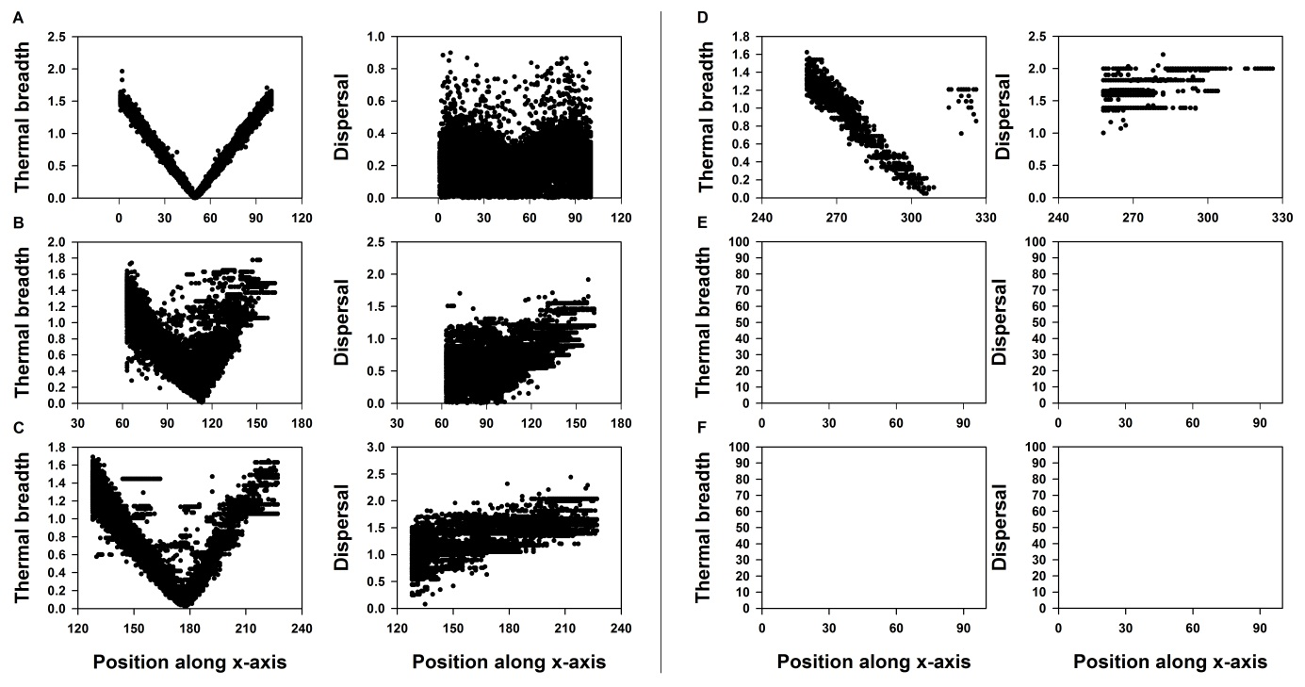

Figure S1.1: Thermal breadth and dispersal are plotted towards position at different time steps (A: equilibrium before range shifting, B: 50 generations of range shifting, C: 100 generations of range shifting, D: 200 generations of range shifting, E: 500 generations of range shifting and F: 1000 generations of range shifting) for a landscape with *P* and *H* equaling 0.2. One dot represents one sampled individual and the global optimum is positioned at respectively the 50th (A), 114th (B), 179th(C), 309th(D), 699th (E) and 1349th (F) column along the x-axis. In case no dots are displayed, no replicate out of the 50 contained a population with more than 1000 individual.

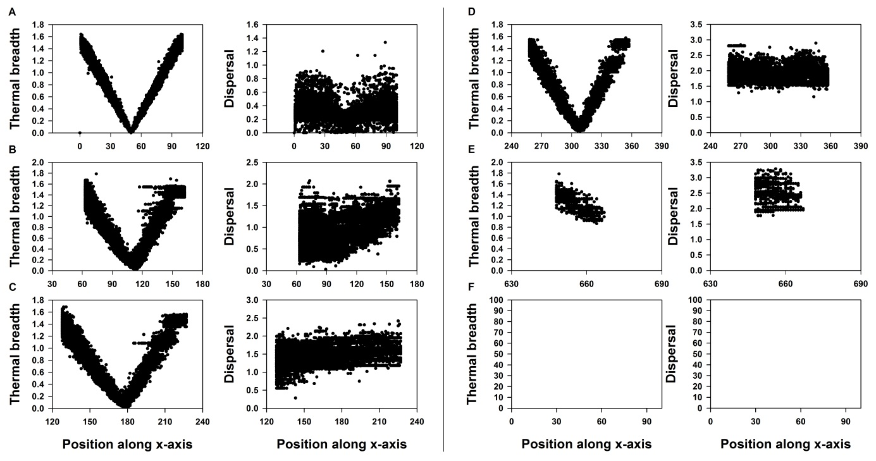

Figure S1.2: Thermal breadth and dispersal are plotted towards position at different time steps (A: equilibrium before range shifting, B: 50 generations of range shifting, C: 100 generations of range shifting, D: 200 generations of range shifting, E: 500 generations of range shifting and F: 1000 generations of range shifting) for a landscape with *P* 0.2 and *H* 0.8. One dot represents one sampled individual and the global optimum is positioned at respectively the 50th (A), 114th (B), 179th(C), 309th(D), 699th (E) and 1349th (F) column along the x-axis. In case no dots are displayed, no replicate out of the 50 contained a population with more than 1000 individual.

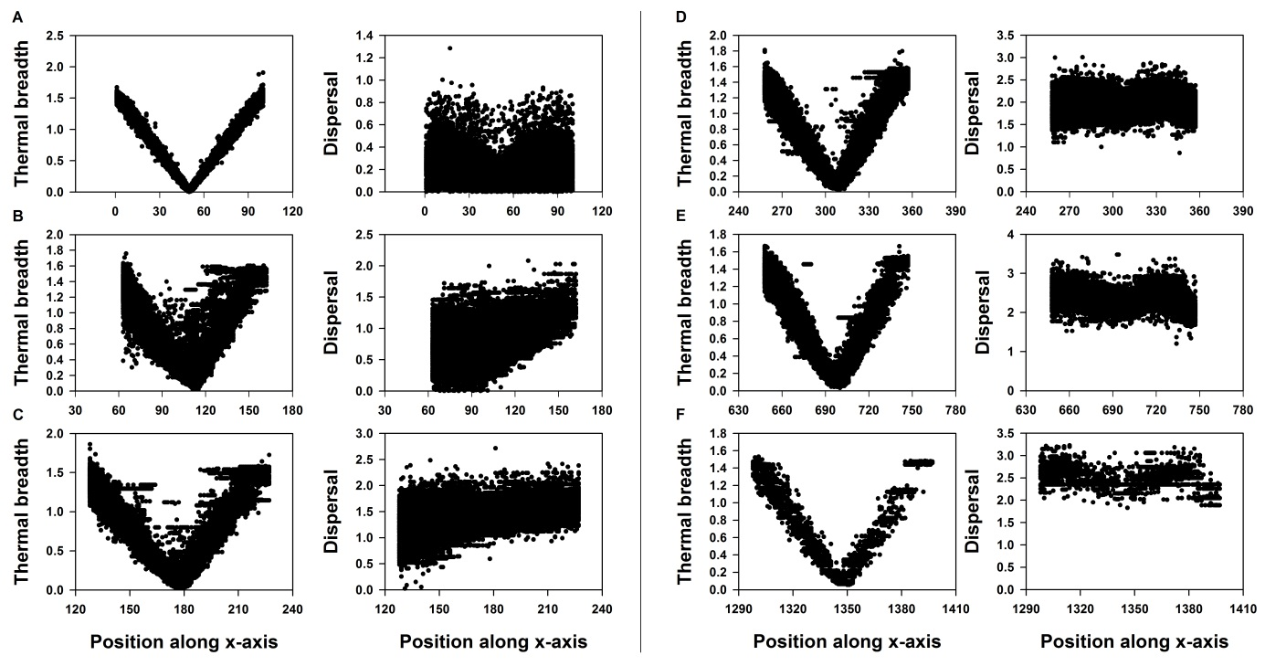

Figure S1.3: Thermal breadth and dispersal are plotted towards position at different time steps (A: equilibrium before range shifting, B: 50 generations of range shifting, C: 100 generations of range shifting, D: 200 generations of range shifting, E: 500 generations of range shifting and F: 1000 generations of range shifting) for a landscape with *P* 0.5 and *H* 0.2. One dot represents one sampled individual and the global optimum is positioned at respectively the 50th (A), 114th (B), 179th(C), 309th(D), 699th (E) and 1349th (F) column along the x-axis. In case no dots are displayed, no replicate out of the 50 contained a population with more than 1000 individual.

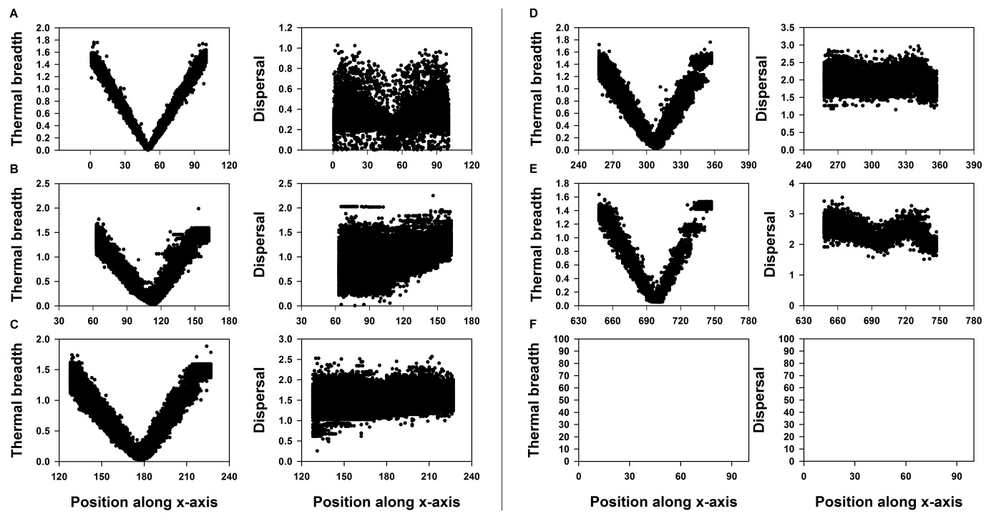

Figure S1.4: Thermal breadth and dispersal are plotted towards position at different time steps (A: equilibrium before range shifting, B: 50 generations of range shifting, C: 100 generations of range shifting, D: 200 generations of range shifting, E: 500 generations of range shifting and F: 1000 generations of range shifting) for a landscape with *P* 0.5 and *H* 0.8. One dot represents one sampled individual and the global optimum is positioned at respectively the 50th (A), 114th (B), 179th(C), 309th(D), 699th (E) and 1349th (F) column along the x-axis. In case no dots are displayed, no replicate out of the 50 contained a population with more than 1000 individual.

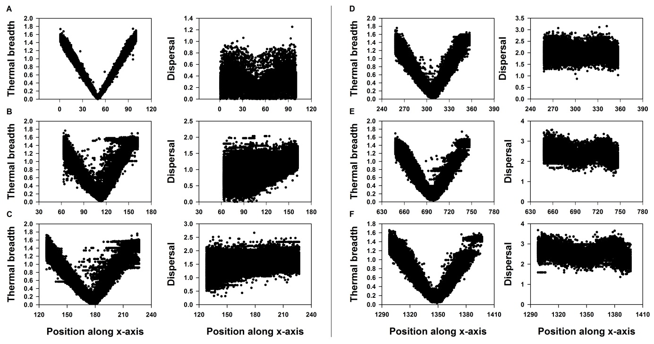

Figure S1.5: Thermal breadth and dispersal are plotted towards position at different time steps (A: equilibrium before range shifting, B: 50 generations of range shifting, C: 100 generations of range shifting, D: 200 generations of range shifting, E: 500 generations of range shifting and F: 1000 generations of range shifting) for a landscape with *P* 0.8 and *H* 0.2. One dot represents one sampled individual and the global optimum is positioned at respectively the 50th (A), 114th (B), 179th(C), 309th(D), 699th (E) and 1349th (F) column along the x-axis. In case no dots are displayed, no replicate out of the 50 contained a population with more than 1000 individual.

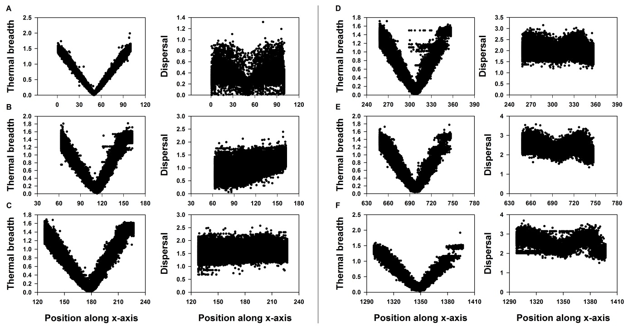

Figure S1.6: Thermal breadth and dispersal are plotted towards position at different time steps (A: equilibrium before range shifting, B: 50 generations of range shifting, C: 100 generations of range shifting, D: 200 generations of range shifting, E: 500 generations of range shifting and F: 1000 generations of range shifting) for a landscape with *P* 0.8 and *H* 0.8. One dot represents one sampled individual and the global optimum is positioned at respectively the 50th (A), 114th (B), 179th(C), 309th(D), 699th (E) and 1349th (F) column along the x-axis. In case no dots are displayed, no replicate out of the 50 contained a population with more than 1000 individual.

## Results: evolutionary dynamics under evolvable optimum (eq(2) and a=10) in contrasting landscape configurations

Testing the effect of landscape configuration for a strong (a=10) performance-thermal breadth trade-off when *xadap* is evolvable. 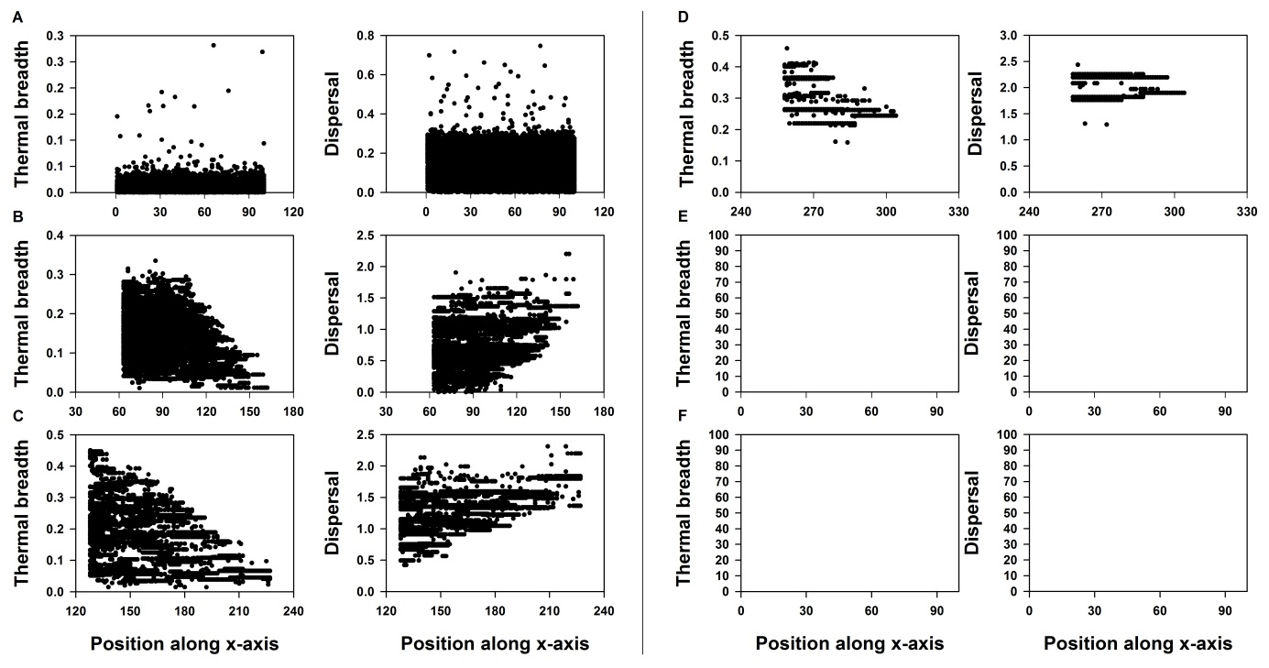 Figure S1.7: Thermal breadth and dispersal are plotted towards position at different time steps (A: equilibrium before range shifting, B: 50 generations of range shifting, C: 100 generations of range shifting, D: 200 generations of range shifting, E: 500 generations of range shifting and F: 1000 generations of range shifting) for a landscape with *P* and *H* equaling 0.2. One dot represents one sampled individual and the global optimum is positioned at respectively the 50th (A), 114th (B), 179th(C), 309th(D), 699th (E) and 1349th (F) column along the x-axis. In case no dots are displayed, no replicate out of the 50 contained a population with more than 1000 individual.

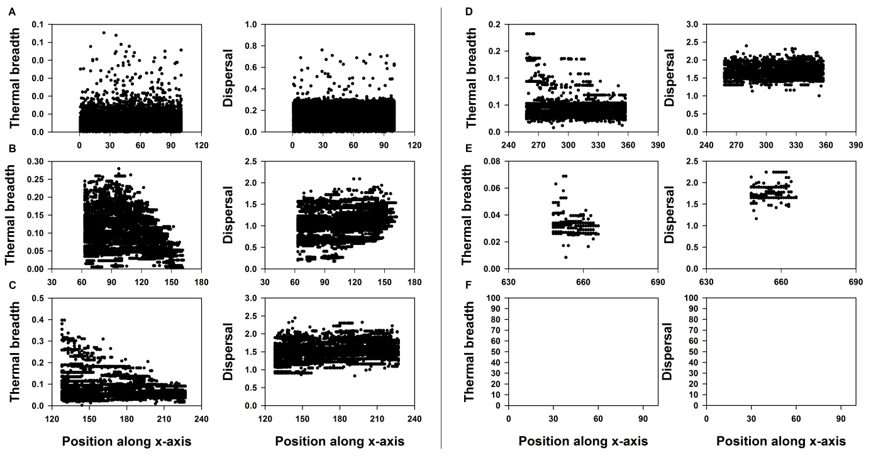 Figure S1.8: Thermal breadth and dispersal are plotted towards position at different time steps (A: equilibrium before range shifting, B: 50 generations of range shifting, C: 100 generations of range shifting, D: 200 generations of range shifting, E: 500 generations of range shifting and F: 1000 generations of range shifting) for a landscape with *P* 0.2 and *H* 0.8. One dot represents one sampled individual and the global optimum is positioned at respectively the 50th (A), 114th (B), 179th(C), 309th(D), 699th (E) and 1349th (F) column along the x-axis. In case no dots are displayed, no replicate out of the 50 contained a population with more than 1000 individual.

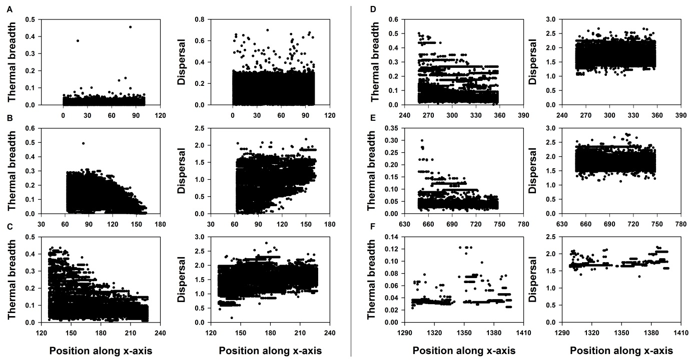

Figure S1.9: Thermal breadth and dispersal are plotted towards position at different time steps (A: equilibrium before range shifting, B: 50 generations of range shifting, C: 100 generations of range shifting, D: 200 generations of range shifting, E: 500 generations of range shifting and F: 1000 generations of range shifting) for a landscape with *P* 0.5 and *H* 0.2. One dot represents one sampled individual and the global optimum is positioned at respectively the 50th (A), 114th (B), 179th(C), 309th(D), 699th (E) and 1349th (F) column along the x-axis. In case no dots are displayed, no replicate out of the 50 contained a population with more than 1000 individual.

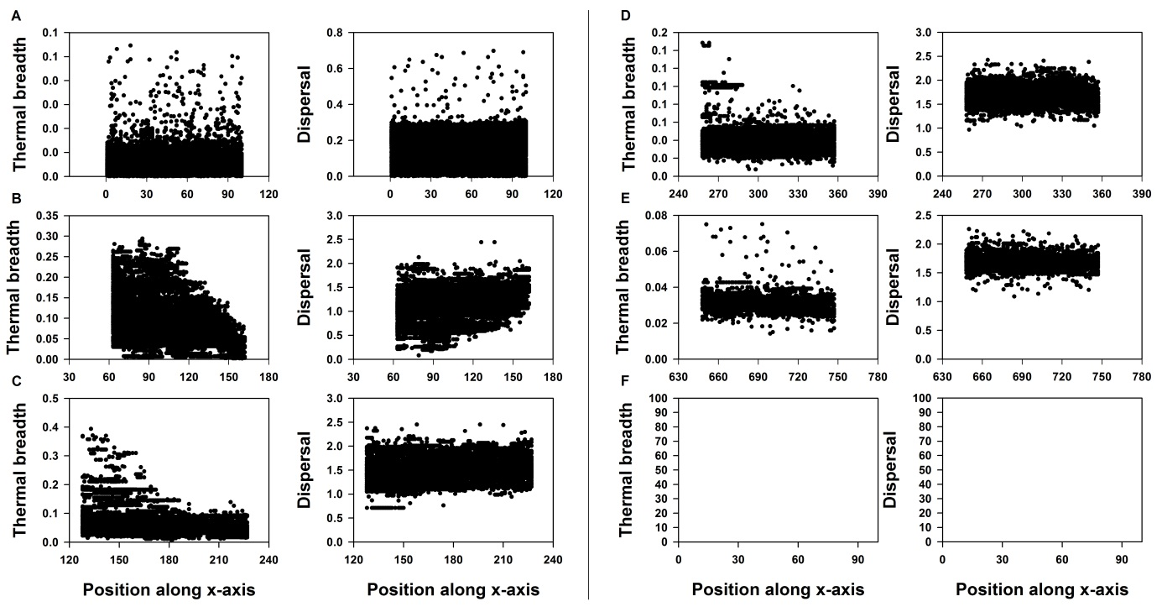

Figure S1.10 Thermal breadth and dispersal are plotted towards position at different time steps (A: equilibrium before range shifting, B: 50 generations of range shifting, C: 100 generations of range shifting, D: 200 generations of range shifting, E: 500 generations of range shifting and F: 1000 generations of range shifting) for a landscape with *P* 0.5 and *H* 0.8. One dot represents one sampled individual and the global optimum is positioned at respectively the 50th (A), 114th (B), 179th(C), 309th(D), 699th (E) and 1349th (F) column along the x-axis. In case no dots are displayed, no replicate out of the 50 contained a population with more than 1000 individual.

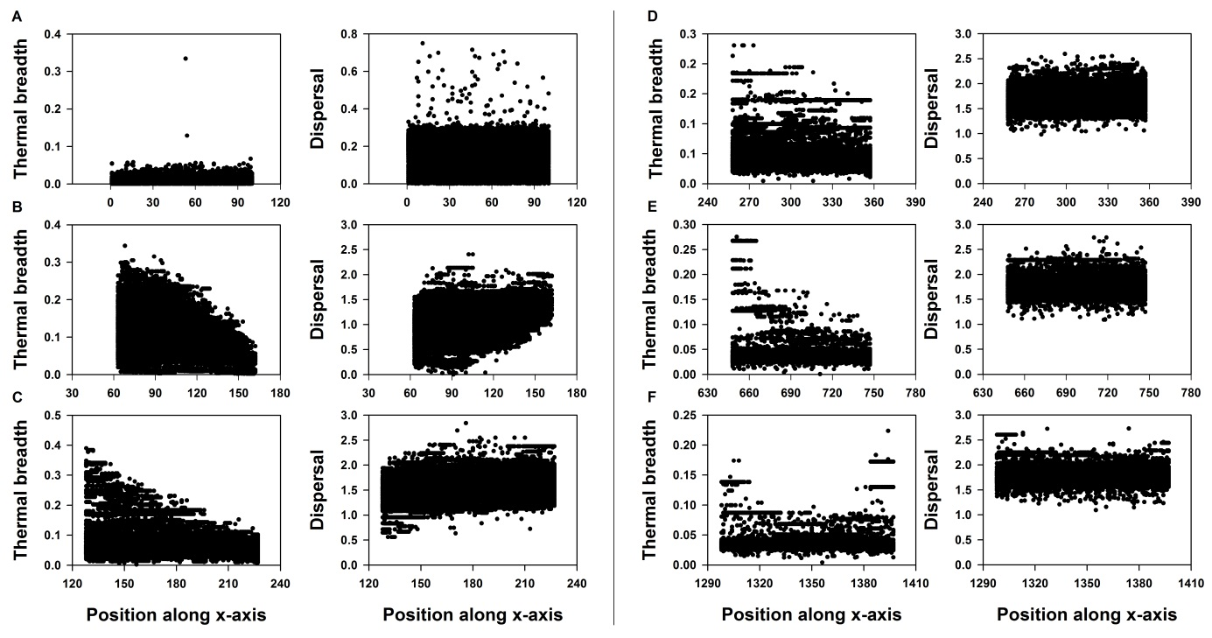

Figure S1.11: Thermal breadth and dispersal are plotted towards position at different time steps (A: equilibrium before range shifting, B: 50 generations of range shifting, C: 100 generations of range shifting, D: 200 generations of range shifting, E: 500 generations of range shifting and F: 1000 generations of range shifting) for a landscape with *P* 0.8 and *H* 0.2. One dot represents one sampled individual and the global optimum is positioned at respectively the 50th (A), 114th (B), 179th(C), 309th(D), 699th (E) and 1349th (F) column along the x-axis. In case no dots are displayed, no replicate out of the 50 contained a population with more than 1000 individual.

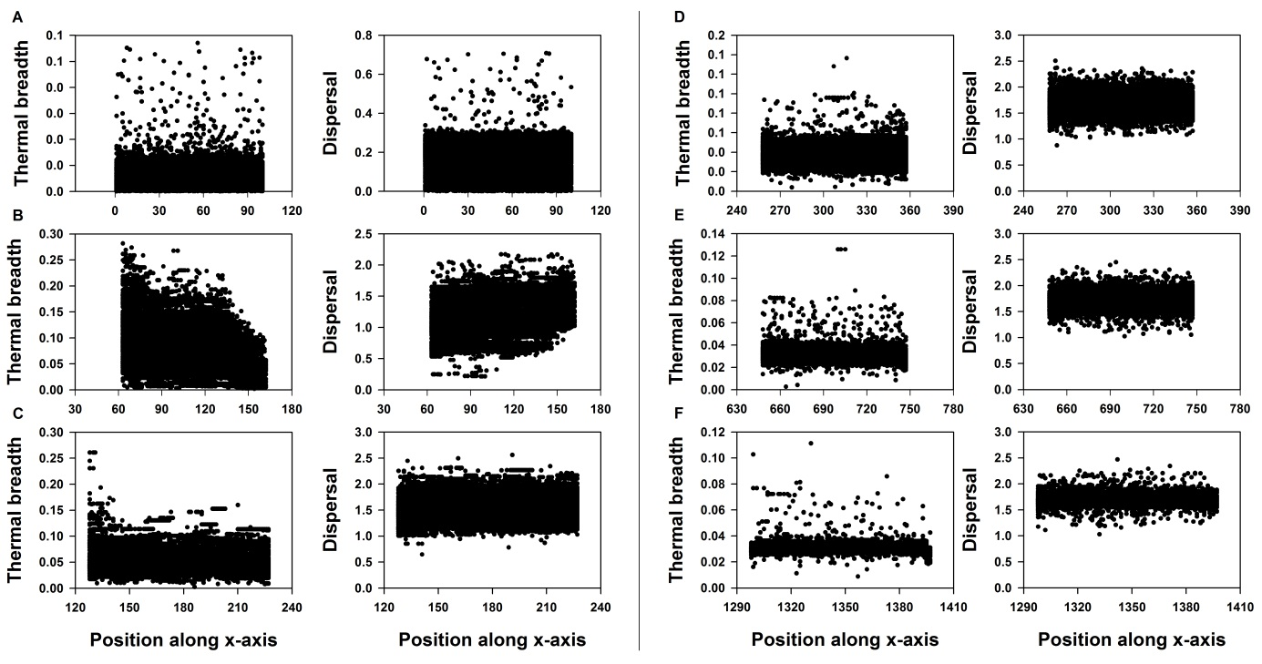

Figure S1.12: Thermal breadth and dispersal are plotted towards position at different time steps (A: equilibrium before range shifting, B: 50 generations of range shifting, C: 100 generations of range shifting, D: 200 generations of range shifting, E: 500 generations of range shifting and F: 1000 generations of range shifting) for a landscape with *P* 0.8 and *H* 0.8. One dot represents one sampled individual and the global optimum is positioned at respectively the 50th (A), 114th (B), 179th(C), 309th(D), 699th (E) and 1349th (F) column along the x-axis. In case no dots are displayed, no replicate out of the 50 contained a population with more than 1000 individual.

## Results: evolutionary dynamics under non-evolvable optimum (eq(2) and a=1) in contrasting landscape configurations

Testing the effect of landscape configuration for a weak (*a*=1) performance-thermal breadth trade-off when *xadap* is not evolvable.

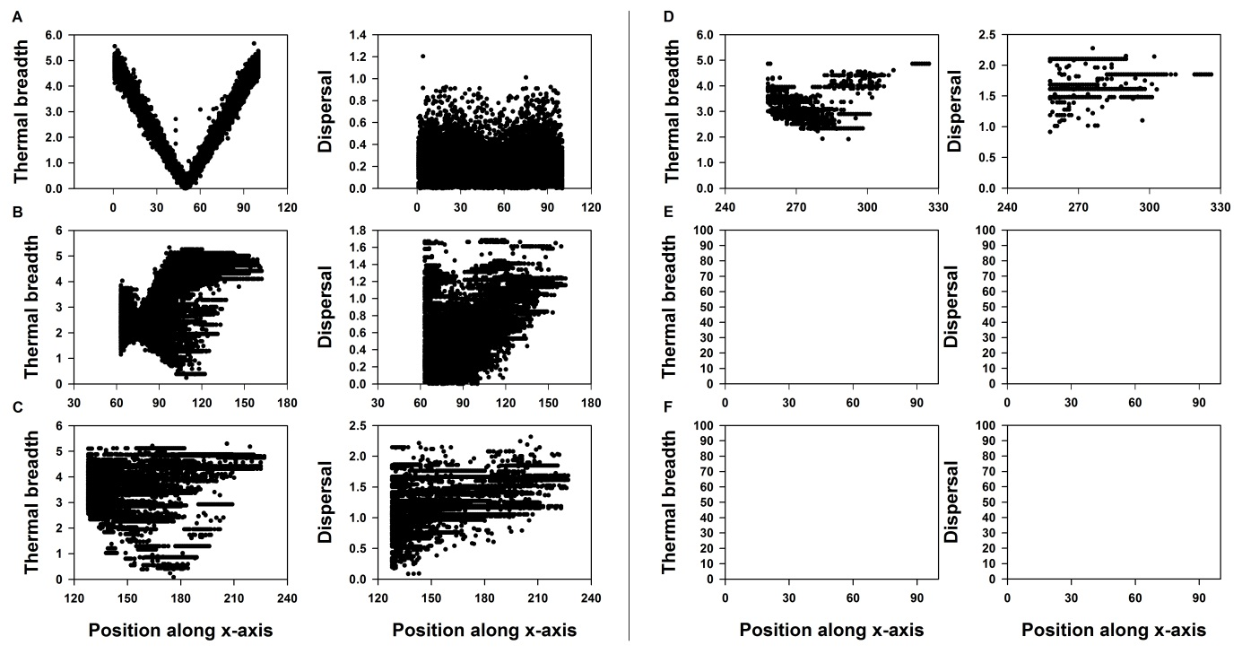

Figure S1.13: Thermal breadth and dispersal are plotted towards position at different time steps (A: equilibrium before range shifting, B: 50 generations of range shifting, C: 100 generations of range shifting, D: 200 generations of range shifting, E: 500 generations of range shifting and F: 1000 generations of range shifting) for a landscape with *P* 0.2 and *H* 0.2. One dot represents one sampled individual and the global optimum is positioned at respectively the 50th (A), 114th (B), 179th(C), 309th(D), 699th (E) and 1349th (F) column along the x-axis. In case no dots are displayed, no replicate out of the 50 contained a population with more than 1000 individual.

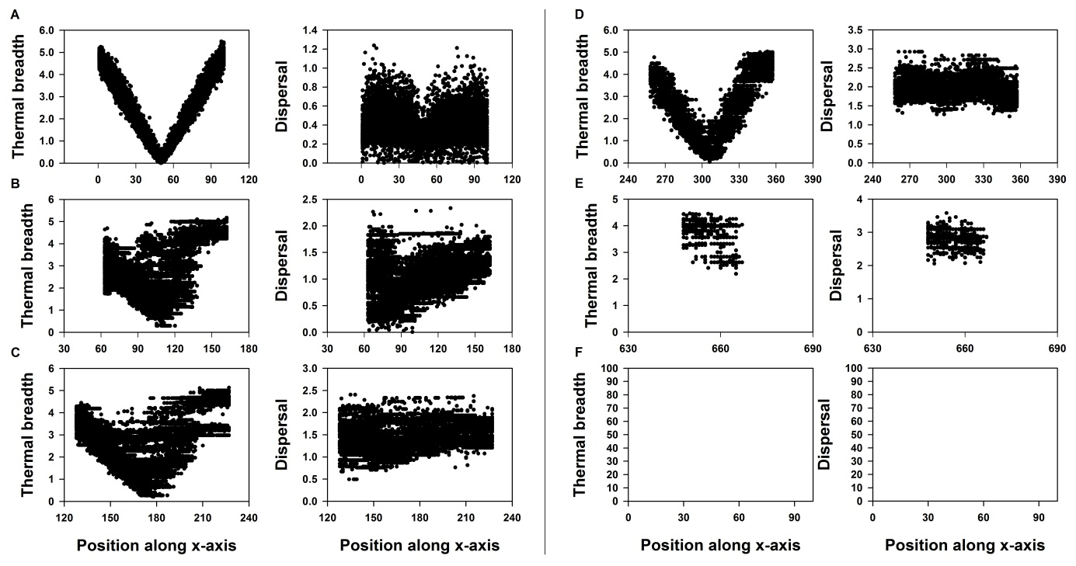

Figure S1.14: Thermal breadth and dispersal are plotted towards position at different time steps (A: equilibrium before range shifting, B: 50 generations of range shifting, C: 100 generations of range shifting, D: 200 generations of range shifting, E: 500 generations of range shifting and F: 1000 generations of range shifting) for a landscape with *P* 0.2 and *H* 0.8. One dot represents one sampled individual and the global optimum is positioned at respectively the 50th (A), 114th (B), 179th(C), 309th(D), 699th (E) and 1349th (F) column along the x-axis. In case no dots are displayed, no replicate out of the 50 contained a population with more than 1000 individual.

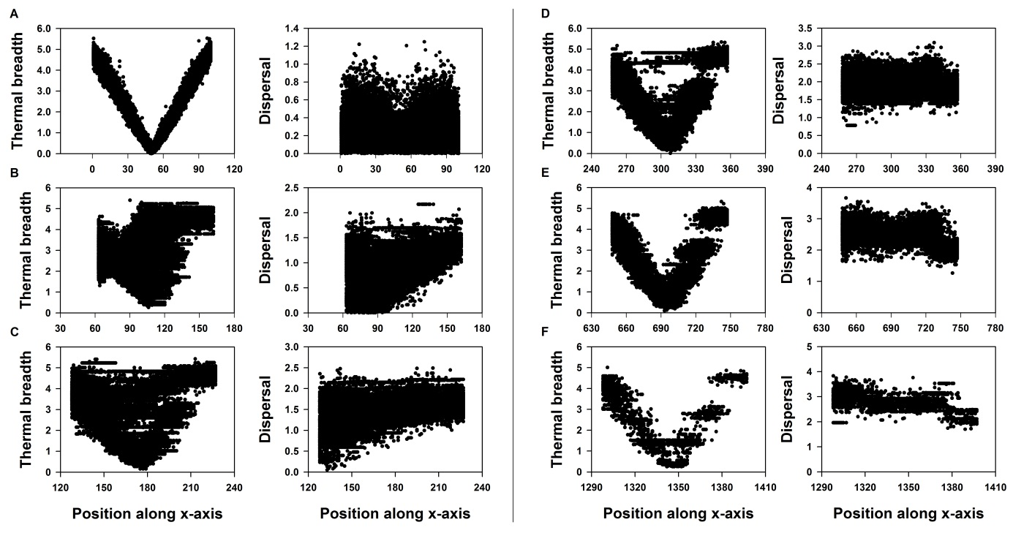

Figure S1.15: Thermal breadth and dispersal are plotted towards position at different time steps (A: equilibrium before range shifting, B: 50 generations of range shifting, C: 100 generations of range shifting, D: 200 generations of range shifting, E: 500 generations of range shifting and F: 1000 generations of range shifting) for a landscape with *P* 0.5 and *H* 0.2. One dot represents one sampled individual and the global optimum is positioned at respectively the 50th (A), 114th (B), 179th(C), 309th(D), 699th (E) and 1349th (F) column along the x-axis. In case no dots are displayed, no replicate out of the 50 contained a population with more than 1000 individual.

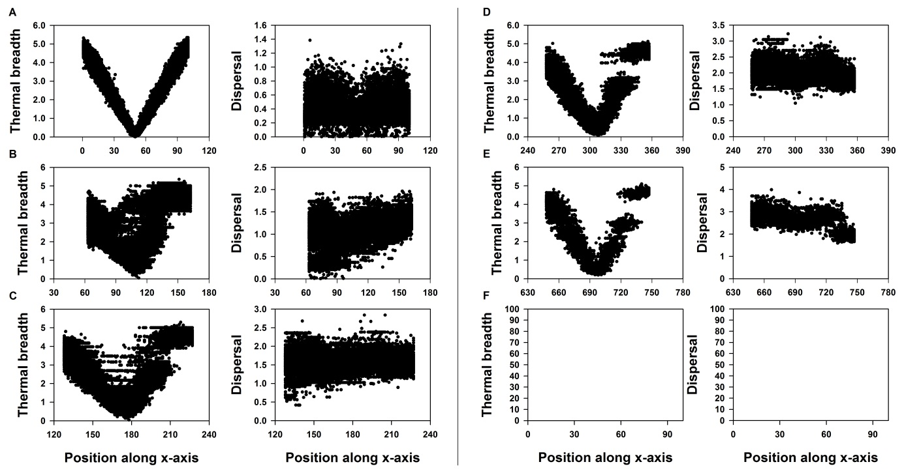

Figure S1.16: Thermal breadth and dispersal are plotted towards position at different time steps (A: equilibrium before range shifting, B: 50 generations of range shifting, C: 100 generations of range shifting, D: 200 generations of range shifting, E: 500 generations of range shifting and F: 1000 generations of range shifting) for a landscape with *P* 0.5 and *H* 0.8. One dot represents one sampled individual and the global optimum is positioned at respectively the 50th (A), 114th (B), 179th(C), 309th(D), 699th (E) and 1349th (F) column along the x-axis. In case no dots are displayed, no replicate out of the 50 contained a population with more than 1000 individual.

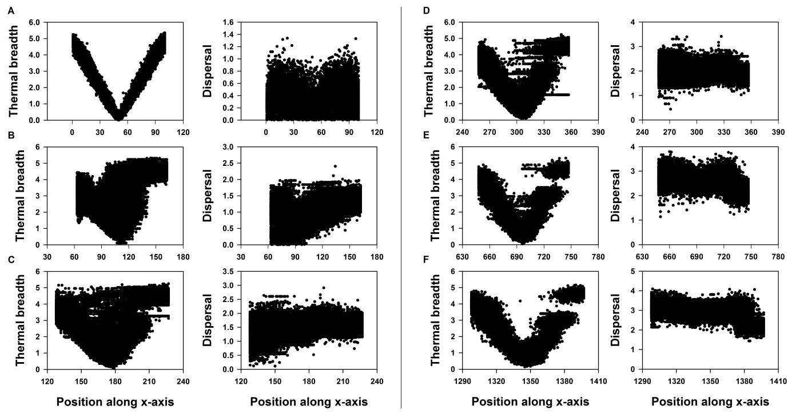

Figure S1.17: Thermal breadth and dispersal are plotted towards position at different time steps (A: equilibrium before range shifting, B: 50 generations of range shifting, C: 100 generations of range shifting, D: 200 generations of range shifting, E: 500 generations of range shifting and F: 1000 generations of range shifting) for a landscape with *P* 0.8 and *H* 0.2. One dot represents one sampled individual and the global optimum is positioned at respectively the 50th (A), 114th (B), 179th(C), 309th(D), 699th (E) and 1349th (F) column along the x-axis. In case no dots are displayed, no replicate out of the 50 contained a population with more than 1000 individual.

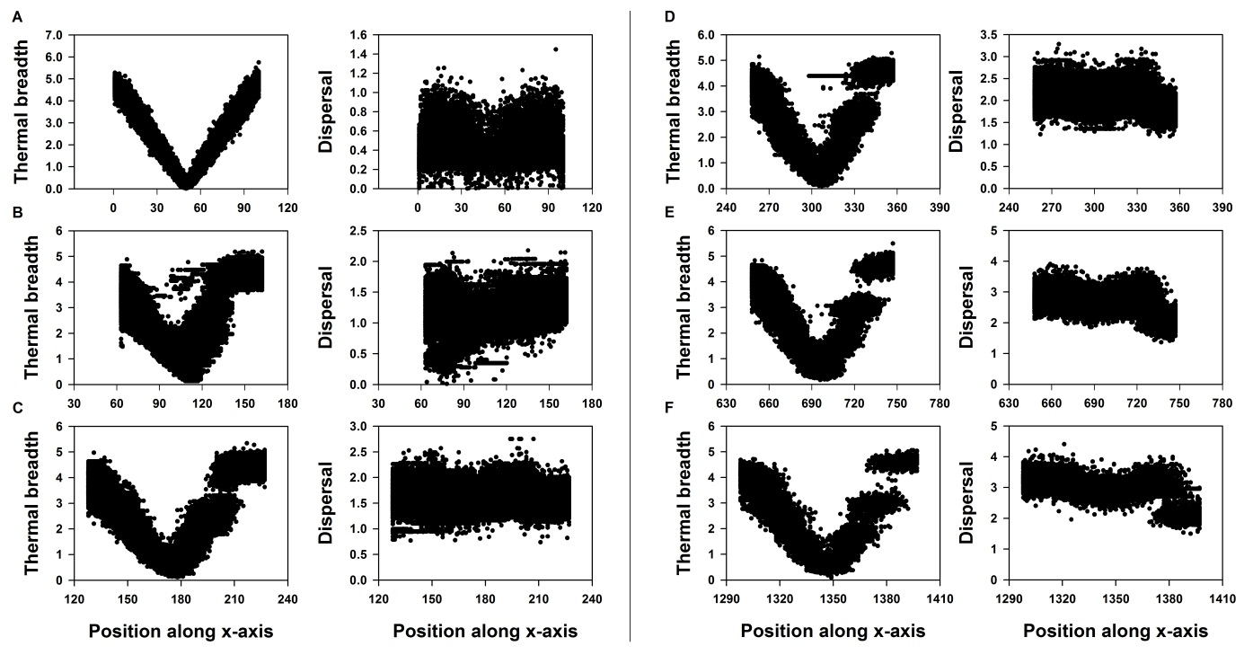

Figure S1.18: Thermal breadth and dispersal are plotted towards position at different time steps (A: equilibrium before range shifting, B: 50 generations of range shifting, C: 100 generations of range shifting, D: 200 generations of range shifting, E: 500 generations of range shifting and F: 1000 generations of range shifting) for a landscape with *P* 0.8 and *H* 0.8. One dot represents one sampled individual and the global optimum is positioned at respectively the 50th (A), 114th (B), 179th(C), 309th(D), 699th (E) and 1349th (F) column along the x-axis. In case no dots are displayed, no replicate out of the 50 contained a population with more than 1000 individual.

## Results: evolutionary dynamics under evolvable optimum (eq(2) and a=1) in contrasting landscape configurations

Testing the effect of landscape configuration for a weak (*a*=1) performance-thermal breadth trade-off when *xadap* is evolvable.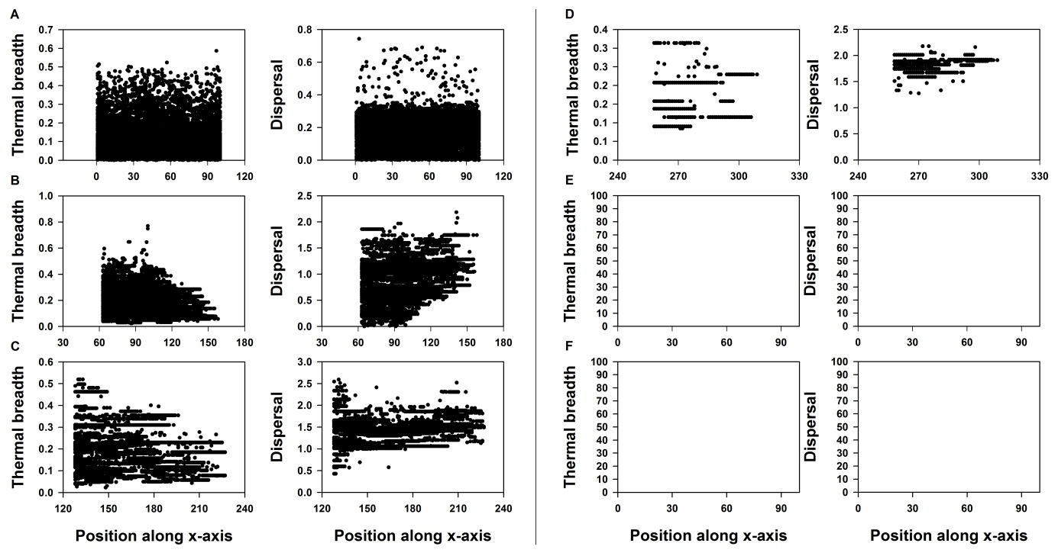

Figure S1.19: Thermal breadth and dispersal are plotted towards position at different time steps (A: equilibrium before range shifting, B: 50 generations of range shifting, C: 100 generations of range shifting, D: 200 generations of range shifting, E: 500 generations of range shifting and F: 1000 generations of range shifting) for a landscape with *P* 0.2 and *H* 0.2. One dot represents one sampled individual and the global optimum is positioned at respectively the 50th (A), 114th (B), 179th(C), 309th(D), 699th (E) and 1349th (F) column along the x-axis. In case no dots are displayed, no replicate out of the 50 contained a population with more than 1000 individual.

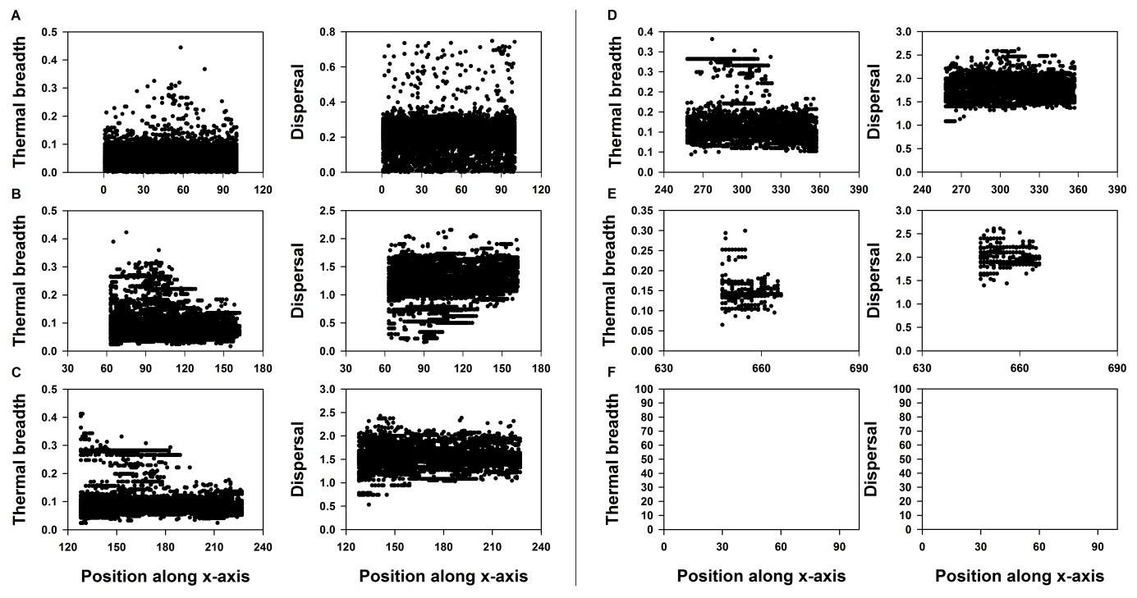

Figure S1.20: Thermal breadth and dispersal are plotted towards position at different time steps (A: equilibrium before range shifting, B: 50 generations of range shifting, C: 100 generations of range shifting, D: 200 generations of range shifting, E: 500 generations of range shifting and F: 1000 generations of range shifting) for a landscape with *P* 0.2 and *H* 0.8. One dot represents one sampled individual and the global optimum is positioned at respectively the 50th (A), 114th (B), 179th(C), 309th(D), 699th (E) and 1349th (F) column along the x-axis. In case no dots are displayed, no replicate out of the 50 contained a population with more than 1000 individual.

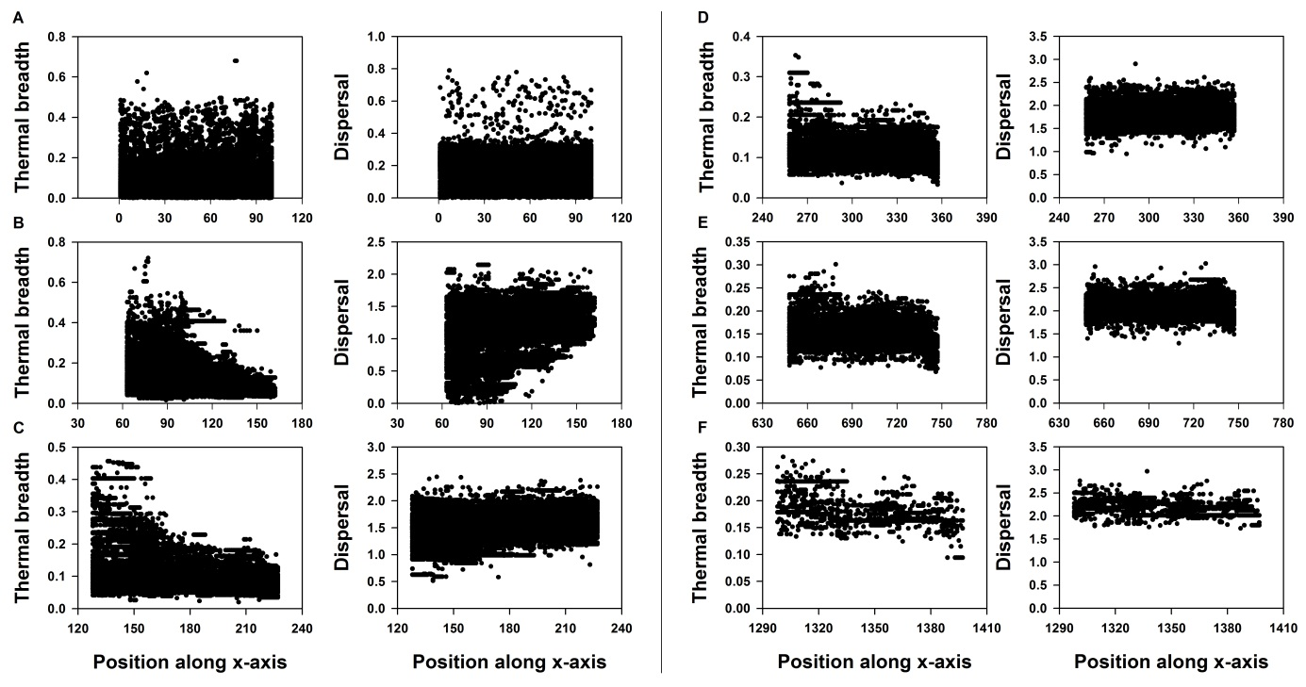

Figure S1.21: Thermal breadth and dispersal are plotted towards position at different time steps (A: equilibrium before range shifting, B: 50 generations of range shifting, C: 100 generations of range shifting, D: 200 generations of range shifting, E: 500 generations of range shifting and F: 1000 generations of range shifting) for a landscape with *P* 0.5 and *H* 0.2. One dot represents one sampled individual and the global optimum is positioned at respectively the 50th (A), 114th (B), 179th(C), 309th(D), 699th (E) and 1349th (F) column along the x-axis. In case no dots are displayed, no replicate out of the 50 contained a population with more than 1000 individual.

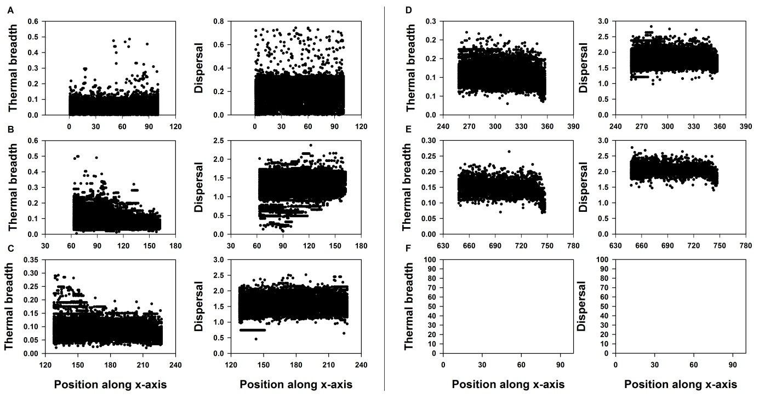

Figure S1.22: Thermal breadth and dispersal are plotted towards position at different time steps (A: equilibrium before range shifting, B: 50 generations of range shifting, C: 100 generations of range shifting, D: 200 generations of range shifting, E: 500 generations of range shifting and F: 1000 generations of range shifting) for a landscape with *P* 0.5 and *H* 0.8. One dot represents one sampled individual and the global optimum is positioned at respectively the 50th (A), 114th (B), 179th(C), 309th(D), 699th (E) and 1349th (F) column along the x-axis. In case no dots are displayed, no replicate out of the 50 contained a population with more than 1000 individual.

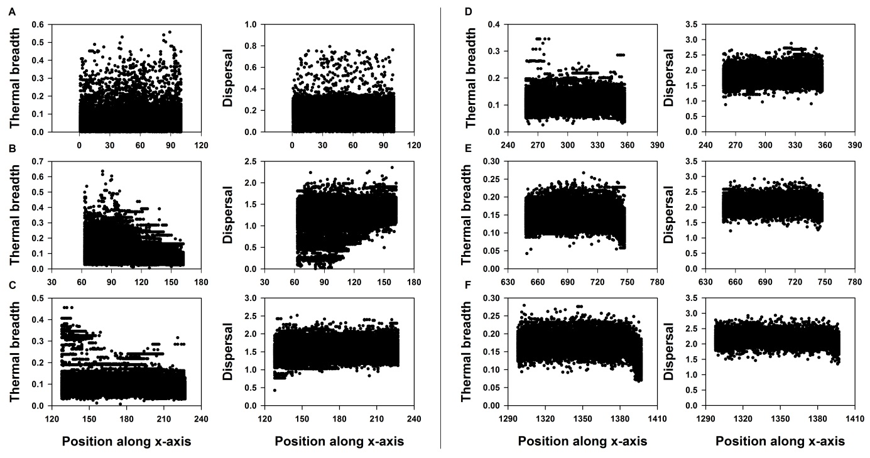

Figure S1.23: Thermal breadth and dispersal are plotted towards position at different time steps (A: equilibrium before range hifting, B: 50 generations of range shifting, C: 100 generations of range shifting, D: 200 generations of range shifting, E: 500 generations of range shifting and F: 1000 generations of range shifting) for a landscape with *P* 0.8 and *H* 0.2. One dot represents one sampled individual and the global optimum is positioned at respectively the 50th (A), 114th (B), 179th(C), 309th(D), 699th (E) and 1349th (F) column along the x-axis. In case no dots are displayed, no replicate out of the 50 contained a population with more than 1000 individual.

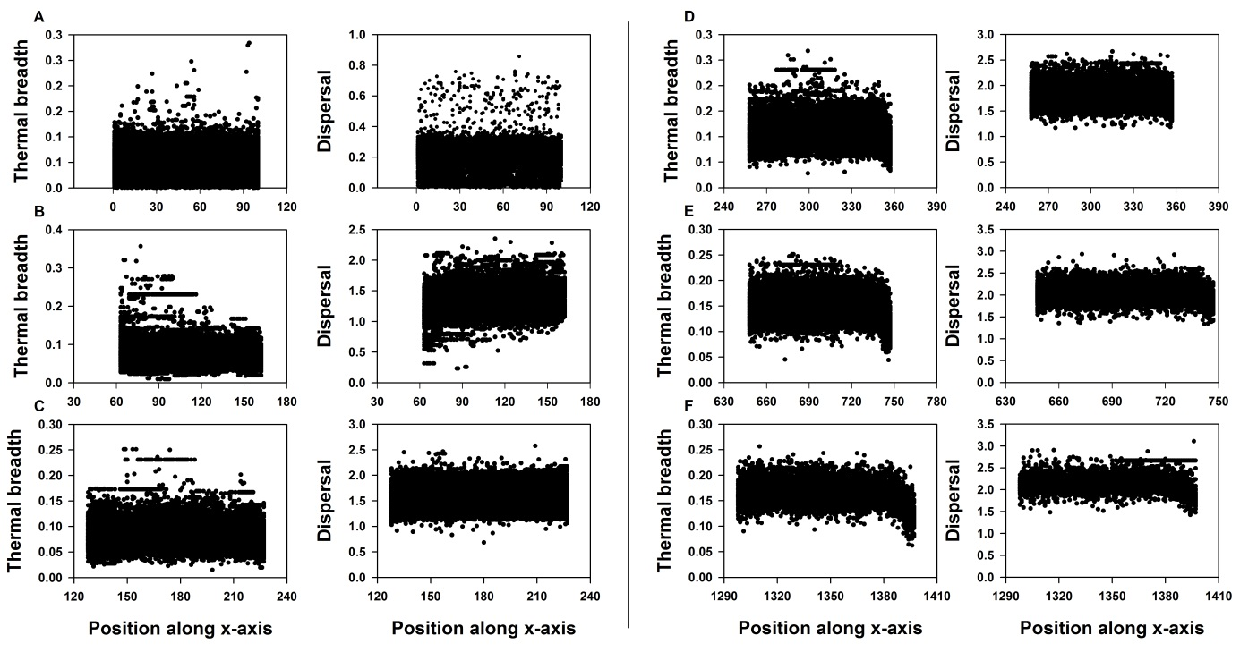

Figure S1.24: Thermal breadth and dispersal are plotted towards position at different time steps (A: equilibrium before range shifting, B: 50 generations of range shifting, C: 100 generations of range shifting, D: 200 generations of range shifting, E: 500 generations of range shifting and F: 1000 generations of range shifting) for a landscape with *P* 0.8 and *H* 0.8. One dot represents one sampled individual and the global optimum is positioned at respectively the 50th (A), 114th (B), 179th(C), 309th(D), 699th (E) and 1349th (F) column along the x-axis. In case no dots are displayed, no replicate out of the 50 contained a population with more than 1000 individual.

## Discussion of the evolutionary dynamics

Evolutionary patterns do not differ substantially between landscape configurations. As demonstrated by others (Travis 2003[4]; McInerny, Travis, and Dytham 2007[5]), the quantity of suitable habitat is positively related with survival probability during range shifting. With increased *H* the chance of encountering gaps lowers, resulting in more successful range shifting on short notice. However, as gaps are larger in landscapes with *H* 0.8 than with *H* 0.2, this is detrimental for survival chances on the long term.

Compared to an evolvable optimum, individuals developed both higher levels of dispersal and broader thermal breadths when the thermal optimum is not evolvable. Not surprisingly, this elevates chances of survival during range shifting (Table S1.1 and S1.2). These results do support the finding of Boeye et al. (2013)[6] that the evolved level of dispersal during range shifting is higher than necessary to keep track of the climate window, although only when the strength of the performance-thermal breadth trade-off is weak. Because an increased strength of this trade-off and an evolvable optimum select for smaller thermal breadths and lower dispersal, the gap crossing ability of a population is decreased and as such also its potential for evolutionary rescue. This is reflected in a larger negative effect of an evolvable thermal optimum on survival chances in different landscapes when the trade-off is strong.

1. Travis, J. M. J. 2003. Climate change and habitat destruction: a deadly anthropogenic cocktail. *Proceedings of the Royal Society of London Series B-Biological Sciences* 270 (1514):467-473.
2. Opdam, P. and D. Wascher. 2004. Climate change meets habitat fragmentation: linking landscape and biogeographical scale levels in research and conservation. *Biological Conservation* 117 (3):285-297.
3. Chipperfield, J. D., C. Dytham, and T. Hovestadt. 2011. An Updated Algorithm for the Generation of Neutral Landscapes by Spectral Synthesis. *Plos One* 6 (2).
4. Travis, J. M. J. 2003. Climate change and habitat destruction: a deadly anthropogenic cocktail. *Proceedings of the Royal Society of London Series B-Biological Sciences* 270 (1514):467-473.
5. McInerny, G., J. M. J. Travis, and C. Dytham. 2007. Range shifting on a fragmented landscape. *Ecological Informatics* 2 (1):1-8.
6. Boeye, J., J. M. J. Travis, R. Stoks, and D. Bonte. 2013. More rapid climate change promotes evolutionary rescue through selection for increased dispersal distance. *Evolutionary Applications* 6 (2):353-364.